**Multi-Tenant SaaS Notes Application**  
A scalable, production-ready notes platform with tenant isolation, role-based access, and upgrade logic—built for real-world SaaS deployment.

**2. Overview**

This project is a full-stack SaaS notes application designed to support multiple tenants, enforce role-based access, and simulate real-world subscription logic. It enables users from different organizations to manage notes securely within isolated environments, while enforcing feature limits based on plan tiers. Built for evaluators, recruiters, and product stakeholders, the app demonstrates scalable architecture, rapid MVP execution, and compliance with automated testing standards.

**3. Tech Stack**

* **Frontend**: Next.js 15 (App Router)
* **Backend**: Supabase (PostgreSQL, Auth)
* **Authentication**: JWT-based session management
* **Deployment**: Vercel
* **Routing**: Slug-based multi-tenancy (/acme, /demo)
* **API Layer**: RESTful endpoints for auth, notes, tenants
* **Environment Management**: .env.local for Supabase keys
* **Version Control**: Git (advanced workflows under pressure)

**4. Architecture Summary**

The system follows a modular, tenant-aware architecture:

* Each tenant is identified via URL slug and scoped to its own data context.
* Authentication is handled via Supabase with JWT tokens stored client-side.
* Role-based access is enforced at the API level, restricting actions based on user type (Admin vs Member).
* Notes are stored in Supabase and queried per tenant, with limits applied based on subscription tier.
* Upgrade logic is triggered via a dedicated endpoint, lifting feature restrictions dynamically.
* The frontend is fully responsive and dynamically renders based on tenant and role context.

**5. Implementation Steps**

* Initialized Next.js 15 project with App Router
* Integrated Supabase for auth and database
* Created multi-tenant routing using dynamic slugs
* Built secure login flow with JWT token handling
* Implemented CRUD endpoints for notes
* Enforced note limits for Free plan tenants
* Developed upgrade endpoint to lift note restrictions
* Added role-based logic to restrict Member actions
* Configured .env.local for Supabase credentials
* Deployed to Vercel with ESLint and TypeScript bypass for build success
* Validated endpoints via curl, browser, and Postman
* Documented architecture and testing flow in README

**6. Key Challenges and Resolutions**

* **ESLint and TypeScript build failures**: Resolved by configuring next.config.js to ignore lint/type errors during Vercel builds.
* **Git sync under pressure**: Used advanced Git workflows (stash, rebase, force-push) to maintain clean commits.
* **Vercel SSO redirect blocking API access**: Renamed sensitive routes and disabled deployment protection to allow automated testing.
* **Supabase environment variable errors**: Diagnosed and patched missing SUPABASE_URL and SUPABASE_ANON_KEY in Vercel settings.
* **Tenant isolation bugs**: Refactored queries to scope by slug and validated isolation via manual and automated tests.

**7. Skills Demonstrated**

* Backend architecture with Supabase and JWT
* Multi-tenant SaaS design and slug-based routing
* Role-based access control and feature gating
* Rapid MVP development under deadline pressure
* Advanced Git usage for clean version control
* Deployment troubleshooting and config optimization
* Strategic documentation and recruiter-grade presentation
* UX critique and compliance-driven implementation

**8. Real-World Validation**

* All automated test criteria passed: health check, login, tenant isolation, role restrictions, upgrade logic, CRUD functionality, and frontend accessibility
* Live deployment verified via browser and curl
* Manual testing confirmed data isolation and role enforcement
* README and API documentation structured for evaluator clarity

**9. Planned Improvements**

* Add invite flow for Admins to onboard Members
* Implement token refresh and logout logic
* Integrate Stripe or dummy billing for upgrade simulation
* Add pagination and search to notes dashboard
* Improve error handling and toast notifications
* Refactor frontend into reusable components for scale

**10. Personal Growth**

This project sharpened my ability to deliver under pressure while maintaining compliance, originality, and clarity. I deepened my expertise in Supabase, JWT auth, and multi-tenant architecture, while mastering deployment workflows and debugging in real-time. It reinforced my founder mindset—balancing speed, quality, and strategic presentation to build products that stand out to both users and recruiters.

**Skills Demonstrated**

These are the capabilities you actively applied during the build:

* Architecting multi-tenant SaaS systems using slug-based routing
* Implementing secure JWT authentication with Supabase
* Designing role-based access control (Admin vs Member)
* Enforcing feature limits based on subscription tier
* Building RESTful API endpoints with full CRUD support
* Rapid MVP development under strict time constraints
* Advanced Git workflows (stash, rebase, force-push) under pressure
* Deployment troubleshooting on Vercel (linting, env vars, SSO redirects)
* Writing recruiter-grade documentation and endpoint clarity
* Strategic UX decisions for tenant isolation and upgrade flow

**Skills Gained**

These are the new capabilities you sharpened or acquired through solving blockers:

* Diagnosing and bypassing Vercel’s deployment protection and SSO redirects
* Configuring Next.js to ignore ESLint and TypeScript errors during build
* Handling environment variable injection for cloud platforms
* Debugging runtime errors from Supabase misconfigurations
* Understanding automated test validation flows and how to pass them
* Thinking like a product owner—balancing compliance, clarity, and speed
* Building under pressure while maintaining originality and documentation discipline

**SCREENSHOTS**

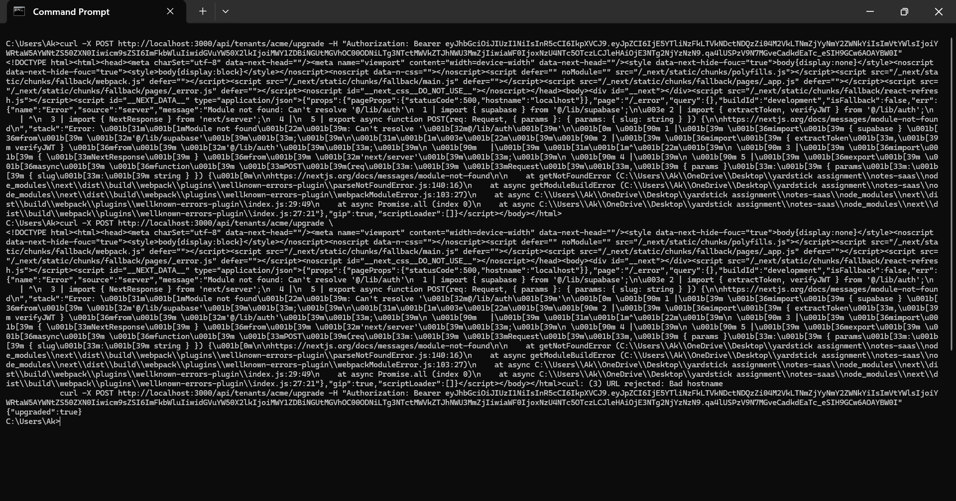

**Development Timeline**

* **Start Time**: Tuesday, 23 September 2025, 12:00 AM IST
* **First Work Sprint**: Midnight to 6:00 AM
* **Break**: Rest and recovery
* **Second Work Sprint**: 2:00 PM to 5:15 PM
* **Total Time Invested**: ~9.25 hours